Compsci 367 Assignment 1

Hasnain Cheena  
190411106  
hche737

**Question 1: Propositional Logic**

1. If A is a base, it is either a purine or a pyrimidine, but not both, similarly for T, C and G.

$$base_{A} ⇒(purine_{A}∨pyrimidine_{A})∧¬\left(purine_{A}∧pyrimidine_{A}\right)$$

$$base_{T} ⇒(purine_{T}∨pyrimidine_{T})∧¬\left(purine_{T}∧pyrimidine_{T}\right)$$

$$base_{G}⇒(purine_{G}∨pyrimidine_{G})∧¬\left(purine_{G}∧pyrimidine_{G}\right)$$

$$base_{C}⇒(purine_{C}∨pyrimidine_{C})∧¬\left(purine_{C}∧pyrimidine_{C}\right)$$

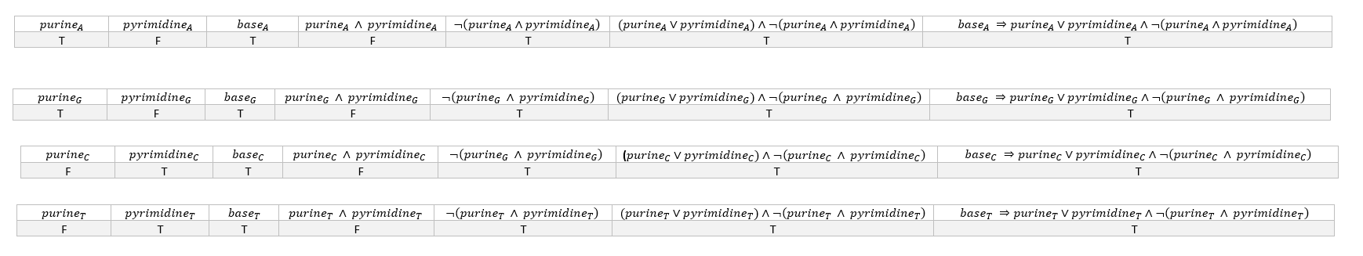

1. If A bonds with C, it does not bond with T or G. Similarly, for the other bases.

$$A_bondswith_T ⇒ ¬(A_bondswith_G) ∨¬(A_bondswith_C)$$

$$A_bondswith_G ⇒ ¬(A_bondswith_T) ∨¬(A_bondswith_C)$$

$$A_bondswith_C ⇒¬(A_bondswith_T )∨¬(A_bondswith_G)$$

$$C_bondswith_G ⇒ ¬(C_bondswith_A) ∨¬(C_bondswith_T)$$

$$C_bondswith_T ⇒ ¬(C_bondswith_A) ∨¬(C_bondswith_G)$$

$$G_bondswith_T ⇒ ¬(G_bondswith_A) ∨¬(G_bondswith_C)$$

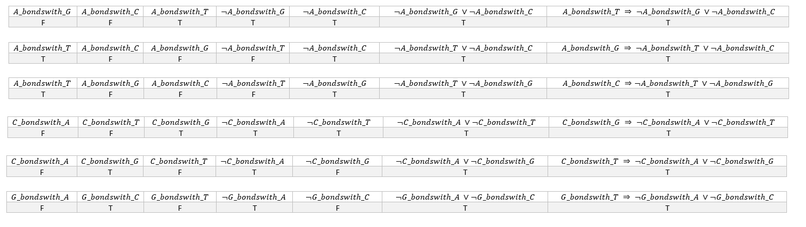

1. A does not bond with A; similarly C, T or G do not bond with themselves.

$$¬A_bondswith_A$$

$$¬G_bondswith_G$$

$$¬T_bondswith_T$$

$$¬C_bondswith_C$$

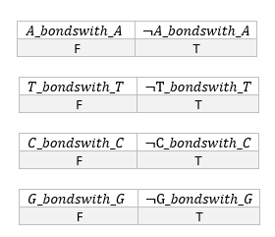

1. If A bonds with T, it is the case that A is a base and that T is a base, and it is either the case that A is a purine and T a pyrimidine, or vice versa. Similarly with other pairs of bases.



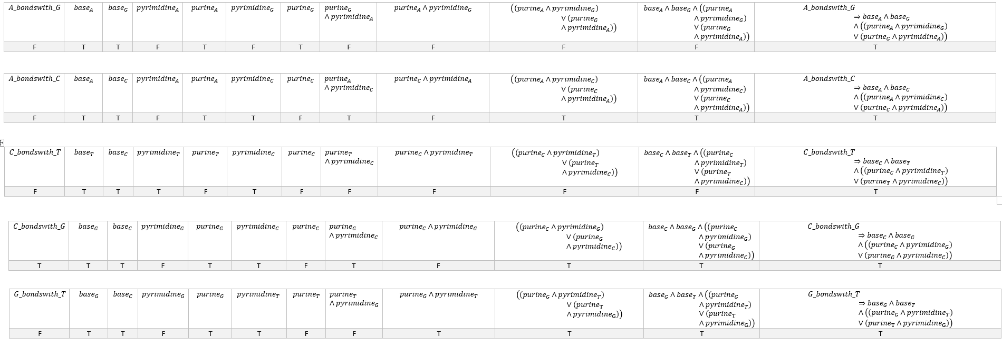

1. If A bonds with T, then T bonds with A, and similarly for all other pairs.

$$A_bondswith_T ⟺T_bondswith_A$$

$$A_bondswith_C ⟺C_bondswith_A$$

$$A_bondswith_G ⟺G_bondswith_A$$

$$C_bondswith_G ⟺G_bondswith_C$$

$$C_bondswith_T ⟺T_bondswith_C$$

$$G_bondswith_T ⟺T_bondswith_G$$

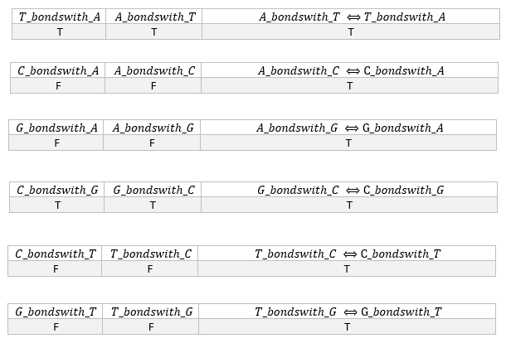

**Question 2 follows on the next page.**

**Question 2: Predicate Logic**

$$∀a \\ base\left(a\right)⇒\left(\left(purine\left(a\right)∨pyrimidine\left(a\right)\right)∧¬\left(purine\left(a\right)∧pyrimidine\left(a\right)\right)\right)$$

$$∀a∃b \\ bondswith\left(a,b\right) ⇒ ¬ ∃z \left(bondswith\left(a,c\right)∧¬\left(b=c\right)\right)$$

$$∀a \\ ¬ bondswith\left(a,a\right)$$

$$∀a∃b \\ bondswith\left(a,b\right) ⇒ base\left(a\right)∧base\left(b\right)∧\left(\left(purine\left(a\right)∧pyrimidine\left(b\right)\right)∨\left(purine\left(b\right)∧pyrimidine\left(a\right)\right)\right)$$

$$∀a∃b \\ bondswith\left(a,b\right)⟺bondswith\left(b,a\right)$$